Data Structure and Algorithm

Laboratory Activity No. 8

Stacks

|  |  |
| --- | --- |
| *Submitted by:* | *Instructor:* |
| Polestico, Paul Justine D. | Engr. Maria Rizette H. Sayo |

October, 04, 2025

# Objectives

Introduction

A stack is a collection of objects that are inserted and removed according to the last-in, first-out (LIFO) principle.

A user may insert objects into a stack at any time, but may only access or remove the most recently inserted object that remains (at the so-called “top” of the stack)

This laboratory activity aims to implement the principles and techniques in:

* Writing Python program using Stack
* Writing a Python program that will implement Stack operations

# Methods

Instruction: Type the python codes below in your Colab. After running your codes, answer the questions below.

# Stack implementation in python

# Creating a stack

def create_stack():

    stack = []

    return stack

# Creating an empty stack

def is_empty(stack):

    return len(stack) == 0

# Adding items into the stack

def push(stack, item):

    stack.append(item)

    print("Pushed Element: " + item)

# Removing an element from the stack

def pop(stack):

    if (is_empty(stack)):

        return "The stack is empty"

    return stack.pop()

stack = create_stack()

push(stack, str(1))

push(stack, str(2))

push(stack, str(3))

push(stack, str(4))

push(stack, str(5))

print("The elements in the stack are:"+ str(stack))

Answer the following questions:

1. Upon typing the codes, what is the name of the abstract data type? How is it implemented?

Answer:

The name of the abstract data type is stack. A stack is a type of data structure that utilizes the Last-In, First-Out principle (LIFO). To put it simply, imagine putting another book into a stack of books. The last book to be put on top of the stack of books mentioned would be the first to be removed,meaning it is in sequential order. You may put other types of books in the stack,but it would still be the first to be removed.

1. What is the output of the codes?

Answer:

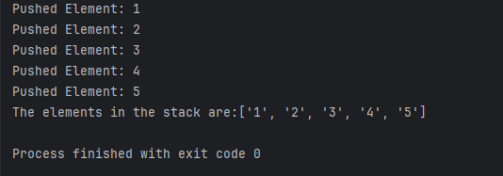

As seen in the output, the first element [1] would be placed in the empty stack,as well as the other elements the user wishes to push. Once done, the elements are now placed inside the stack in sequential order, demonstrating the importance of stacks.

1. If you want to type additional codes, what will be the statement to pop 3 elements from the top of the stack?

Answer:

For this problem, i decided to use the pop function. At first,i tried to remove 3 elements all at once only to discover that it would produce an error if executed. As i soon realized that stacks are meant to be removed one by one, i used the pop function to remove each element one by one,allowing me to remove three elements from the top of the stack.

1. If you will revise the codes, what will be the statement to determine the length of the stack? (Note: You may add additional methods to count the no. of elements in the stack)

Answer:

As discussed in the lesson about stacks, Python has a built in function to determine the length of the stack called the len function. This built in function helped simplify the entire code while also getting the desired result required from the question. This also allowed showcasing the differences in length before and after the removal of 3 elements from the stack.

# Results



Figure 1 Screenshot of program

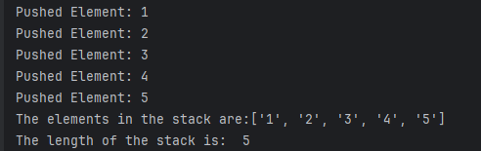

Figure 2 Screenshot of program

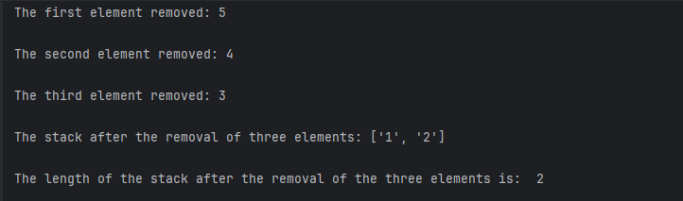

Figure 3 Screenshot of program

Conclusion

This laboratory activity demonstrates the implementation of stacks in data processing. The researcher has gained knowledge not only on the importance of stacks, but also the application of such in the real world. Stacks are one of the most essential types of data in various industries which include programming, business, and many more.

**References**

[1] Co Arthur O.. “University of Caloocan City Computer Engineering Department Honor Code,” UCC-CpE Departmental Policies, 2020.